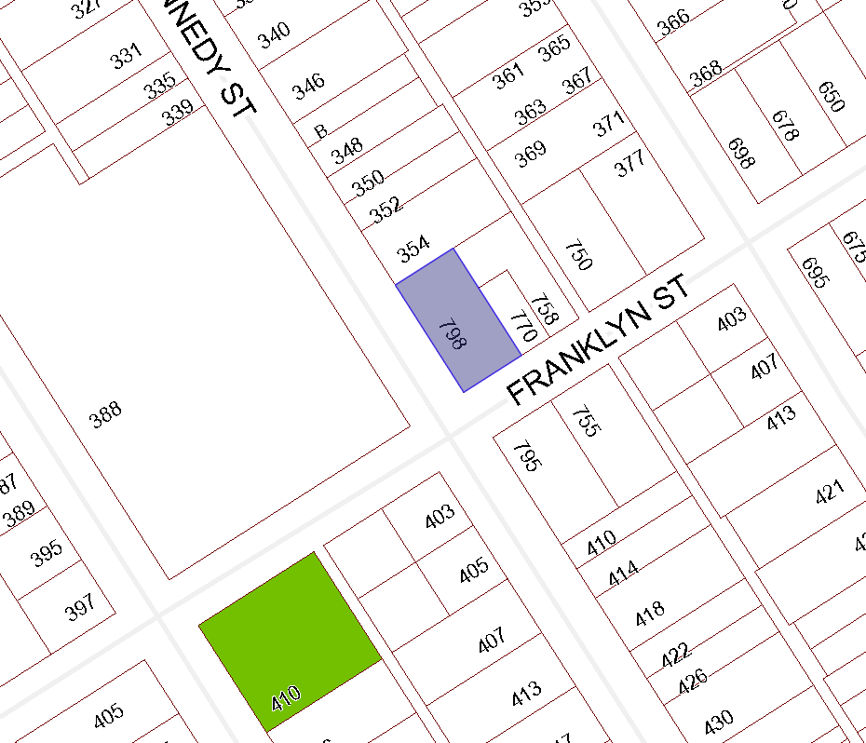

BOARD OF VARIANCE APPLICATION BOV00662

LOCATION MAP

CIVIC: 798 Franklyn Street

LEGAL: SECTION A, OF LOT 8, BLOCK J, SECTION 1, NANAIMO DISTRICT, PLAN 584

